COMMON COURSE ASSIGNMENT FORMAT

Assignment Information

Particular | Details
Department: | COMPUTER SCIENCE ENGINEERING
Programme: | BE
Course Code & Course Name | CSA0315-DATA STRUCTURES
Academic Year / Batch | 2026/2022
Faculty Name | DR.T.RAJESH KUMAR
Assignment Title | "Design of a Collision-Resilient Hash-Based Caching System for High-Throughput Product Lookups in E-Commerce "
Date of Issue | 02/09/2026
Date of Submission | 03/09/2026
Maximum Marks | 100
Course Outcome(s) – CO | "Design of a Collision-Resilient Hash-Based Caching System for High-Throughput Product Lookups in E-Commerce "
Bloom's Taxonomy Level | L4 – Analyze,L5 - Evaluate
SDG Mapping (SDG 1-17) | SDG 9 - Industry, Innovation, and Infrastructure SDG 11 – Sustainable Cities and Communities;
Industry / Societal Relevance | Product-catalog search caching, database indexing,  session/token stores. Compiler symbol tables, spell-checkers

1. Problem Statement
A large e-commerce company is designing a high-speed product search and recommendation system that stores information about millions of products. Customers should be able to search products using keywords, product names, categories, and product identifiers. The system should normally return search results within 100 ms.
Users may enter either partial or complete search terms such as “lap”, “laptop”, or “laptop stand”. Since products are continuously inserted, deleted, and updated, the system must efficiently handle dynamic changes. It should support both exact-match and prefix-based searches, control memory consumption, and efficiently process frequently repeated queries.
The engineering team is evaluating arrays, linked lists, binary search, hash tables, tries, suffix arrays, and LCP arrays to identify the most appropriate data structures for the system.

2. Objective
The main objectives of the system are:
- To design a fast product-search system suitable for millions of product records.
- To support efficient exact-match searches using appropriate data structures.
- To support prefix-based searches and autocomplete for partial queries.
- To handle frequent product insertion, deletion, and update operations.
- To reduce response time for frequently repeated queries using caching.

3. Requirements and Environment Used Hardware Requirements
- Processor: Intel Core i3 or above
- RAM: 4 GB or above
- Storage: 500 MB minimum
- Keyboard and monitor

Software Requirements
- Operating System: Windows / Linux / macOS
- Programming Language: C
- Compiler: GCC / MinGW
- IDE: Visual Studio Code / Code: Blocks / Dev-C++
- Terminal/Command Prompt for execution

Functional Requirements
- Product insertion
- Product deletion
- Product update
- Exact product search
- Prefix-based product search
- Category search
- Product-ID search
- Frequently repeated query handling
- Display of matching products

Non-Functional Requirements
- Search response should normally be within 100 ms
- Efficient memory utilization
- Support millions of records
- Fast updates
- Scalable search infrastructure

4. Design / Proposed Solution
Requirement | Proposed Data Structure
Exact product-ID search | Hash Table
Exact product-name search | Hash Table
Prefix search | Trie
Repeated queries | Hash-based Query Cache
Product storage | Dynamic structures
Product updates | Hash-based indexing

Why Hash Table?
A hash table provides approximately O(1) average-case search for exact keys such as:
Product ID = P1001 Product Name = "Laptop"
Why Trie?
A Trie is suitable for prefix searches:
+-- laptop
+-- laptop stand
+-- laptop bag
+-- laptop charger
The search time is approximately: O (k + r) where k is the length of the prefix and r is the number of results returned.

Query Cache:
Frequently repeated queries can be stored in a hash-based cache:
"laptop" → Product Results
"mobile" → Product Results
"laptop stand" → Product Results
This avoids performing the same search repeatedly.

5. Algorithm / Pseudocode / Flowchart

A. Exact Search Algorithm
Exact Product Search
- Start
- Read the product identifier/name.
- Calculate the hash value of the search key.
- Access the corresponding hash-table location.
- Compare the stored key with the search key.
- If a match is found:
Display product details.
- Otherwise:
Display "Product not found".
- Stop.
Complexity
Average Time: O (1)

B. Prefix Search Algorithm
Prefix Product Search
- Start
- Read the prefix entered by the user.
- Start from the root of the Trie.
- For each character in the prefix:
  - Find the corresponding Trie node.
  - If the node does not exist:
Display "No products found".
Stop.
- After reaching the prefix node, traverse all its child nodes.
- Collect matching products.
- Display the results.
- Stop.
Complexity O (k + r) where:
  - k = prefix length
  - r = number of matching results.

C. Query Cache Algorithm
Query Cache
- Start
- Read the user's query.
- Search the query in the cache.
- If query exists:
Return cached results.
- Otherwise:
Perform normal product search.
Store the results in the cache.
Return the results.
- Stop.

6. Implementation

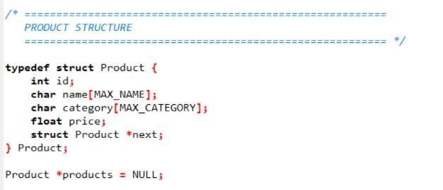

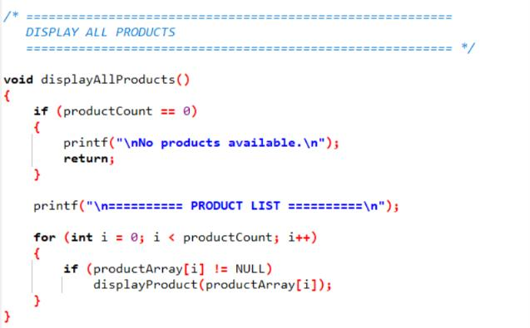

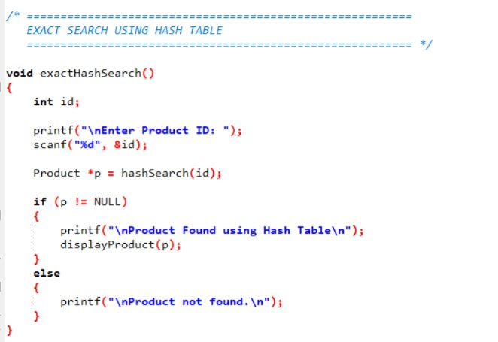

7. Test Cases and Expected/Actual Results
Test Case | Input | Expected Result | Actual Result
TC01 | Product ID 1001 | Product found | Product found
TC02 | Product ID 9999 | Product not found | Product not found
TC03 | laptop | Display laptop products | Displayed
TC04 | lap | Display all products beginning with "lap" | Displayed
TC05 | laptop stand | Display matching products | Displayed
TC06 | Insert new product | Product added | Product added
TC07 | Delete product | Product removed | Product removed
TC08 | Update product price | Updated price displayed | Updated
TC09 | Repeat laptop query | Return cached result | Cached result returned
TC10 | Invalid search | No matching product | Correct message displayed

8. Execution Screenshots

Program Main Menu
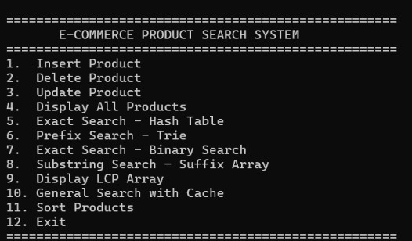

Product Insertion
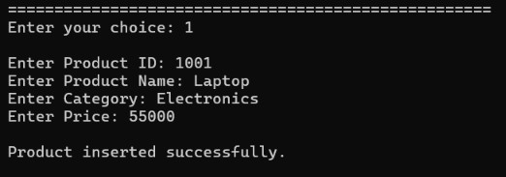

Exact Search Using Hash Table
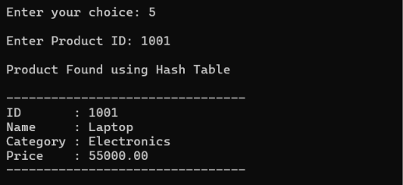

Display All Products


Prefix Search Using Trie


Binary Search
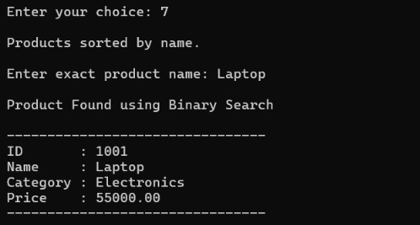

Suffix Array Search
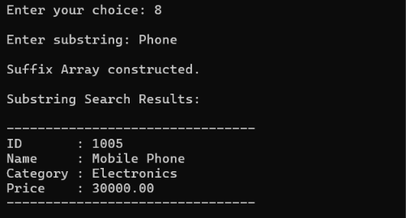

LCP Array
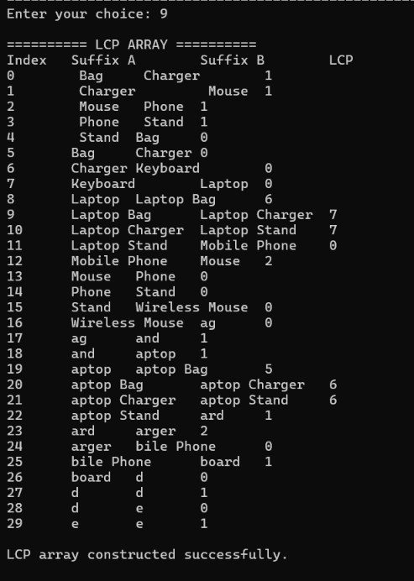

Query Cache


9. Analysis and Discussion
The different data structures were compared based on search performance, update efficiency, memory consumption, and suitability for dynamic product databases.
Array:
Arrays provide simple storage but searching an unsorted array requires O(n) time.
This is inefficient when millions of products are present.
Linked List:
Linked lists also require O(n) search time. Although insertion and deletion can be efficient at a known position, they are unsuitable for high-speed product searching.
Binary Search:
Binary search provides O(log n) search on sorted data. However, maintaining sorted data becomes expensive when products are continuously inserted, deleted, and updated.
Hash Table:
Hash tables provide approximately O(1) average-case exact search, making them highly suitable for product IDs and exact names.
Trie:
Tries are highly suitable for prefix-based searches and autocomplete. Their search depends primarily on the length of the query rather than the total number of products.

Therefore, they are not preferred as the primary indexing mechanism for this dynamic system.

10. Conclusion
The E-Commerce Product Search and Recommendation System requires data structures that can efficiently handle millions of dynamically changing product records. After comparing arrays, linked lists, binary search, hash tables, tries, suffix arrays, and LCP arrays, a hybrid approach using Hash Tables, Tries, and a Query Cache is proposed.
The Hash Table provides efficient exact-match searches, while the Trie supports prefix-based searches such as "lap" and "laptop". A query cache further improves performance for frequently repeated searches. This design provides an effective balance between search speed, dynamic updates, memory usage, and scalability.

11. Individual Contribution of Group Members
Group Member | Contribution
G MANISH | Contributed to debugging and correcting errors encountered during implementation.  Assisted in preparing the Results, Testing, and Validation section of the report.

12. References
- Herbert Schildt, C: The Complete Reference, McGraw-Hill Education.
- Ellis Horowitz, Sartaj Sahni, and Susan Anderson-Freed, Fundamentals of Data Structures in C, W. H. Freeman.
- Thomas H. Carmen, Charles E. Leiserson, Ronald L. Rivest, and Clifford Stein, Introduction to Algorithms, MIT Press.
- Robert Lafore, Data Structures and Algorithms in C, Pearson Education.
- Department of Computer Science and Engineering, Data Structures Laboratory Course Notes and Materials.

13. One Page Writeup

Introduction
A large e-commerce platform may contain millions of product records that must be searched quickly and efficiently. Customers may search using product identifiers, product names, categories, keywords, or partial words. Therefore, the search system must provide fast results while also supporting continuous insertion, deletion, and updating of products.

Proposed Solution
A hybrid data-structure approach is proposed for the system. A Hash Table is used for exact-match searches such as product IDs and exact product names. Hash tables provide approximately O (1) average-case search, making them suitable for highspeed lookups. A Trie is used for prefix-based searches and autocomplete. For example, when a customer enters "lap", the Trie can efficiently retrieve products such as "laptop", "laptop stand", and "laptop bag".
A Hash-based Query Cache is also included to handle frequently repeated searches. When a query is received, the system first checks whether the result is already present in the cache. If it is present, the cached result is returned directly. Otherwise, the appropriate search structure is used and the resulting data is stored in the cache for future requests.

Data Structure Analysis
Arrays and linked lists are not suitable as the primary search structures because their search operations generally require O(n) time. Binary search provides O(log n) searching but requires sorted data, making frequent updates expensive. Hash tables are highly efficient for exact searches, while Tries are particularly effective for prefix searches. Suffix arrays and LCP arrays can support advanced substring searching but are less suitable for a system with continuous product updates because maintaining their indexes can be expensive.

Expected Outcome
The proposed Hash Table + Trie + Query Cache architecture provides efficient searching while supporting dynamic product operations. Exact searches can be performed using the hash table, prefix searches can be performed using the Trie, and repeated queries can be accelerated through caching. The design therefore provides a scalable and practical solution for an e-commerce environment containing millions of products. Conclusion
The analysis shows that no single data structure is ideal for every requirement. A hybrid approach provides better performance and flexibility. The combination of Hash Tables for exact matching, Tries for prefix searching, and a Query Cache for repeated queries offers an effective solution for high-speed e-commerce product search while maintaining support for dynamic updates and large-scale product data.

